Diary of a HTM 6th Grader Planning Sheet Name: __________________________________

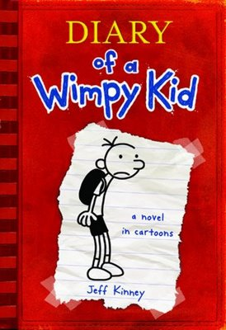 | For our Celebrations of Learning, we will each create our own “Diary of a HTM 6th Grader” to reflect on our growth this year. They will be modeled after the Diary of a Wimpy Kid series and will include short anecdotes, experiences and simple pictures. Our hope is that your diaries will include tips and advice on how to be a HTM student and will be given to next year’s class of 6th graders to use as a reference and guidebook.  Below in the left column is a list of ideas for each of the five chapters in your diary. If you have another idea for what you would like to write about, please talk to your teacher. The right column includes sentences starters that are optional for each chapter.
Directions: For each of the four chapters come up with a list of ideas for what to write about and draw for each chapter. Each box should have at least 4 bullet points and one sketch. Last, come up with your own title for each chapter.

Chapter Ideas | Sentence Suggestions
Chapter 1: What I was like at the beginning of the year…  Example Title:  The Old Me  Your Chapter title: | Describe who you were and how you felt, before your first day of 6th grade:  I used to be…  I used to think…  On the first day of school, I felt…  Sketch at least ONE image for this chapter:
Chapter 2: I’ve dealt with challenges and made some mistakes…  Example Title:  Collaboration Catastrophe  Your Chapter title: | Describe a time this year when you faced a challenge or made a mistake. How did you overcome your challenge? What would you have done differently?  One challenge I faced this year was…  Looking back, one mistake I made was…  I overcame this challenge by...  If I could do it differently, I would...  Sketch at least ONE image for this chapter:
Chapter 3: I’ve had some moments when I felt really proud and really successful…  Example Title:  Leader of the LARPers  Your Chapter title: | Describe a time this year when you felt really proud of yourself:  One thing I made/did this year that I am really proud of is…  I feel I really grew as a learner when…  One example of a time when I put forth my best effort is…  Sketch at least ONE image for this chapter:
Chapter 4: What I want you to know about the HTM 6th grade experience is…  Example Title:  Survival  Your Chapter title: | What advice do you have for an incoming 6th grader. Think about…  Doing projects, making friends, managing time wisely, working with teachers  Sketch at least ONE image for this chapter:
Chapter 5: Who I am now as a 7th grader…  Example Title:  Me 2.0  Your Chapter Title: | Describe how you or your beliefs about yourself have changed this year. Who are you now? How have you grown as a person since the beginning of the year?  Before, I was __________, now I am…  I have grown in…  Now at the end of the year, I feel…  Sketch at least ONE image for this chapter:

