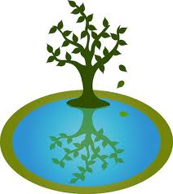
Name___________________________________ Class_____________________ Date_________________

Self-Reflection Form

Weeks ___________________________________
Affirmations
Professional | Inquisitive | Supportive | Respectful | Confident
Inspirational | Hardworking | Appreciative | Open-Minded | Creative

An affirmation I feel I achieved was _______________________________. I did this by _________________________
_________________________________________________________________________________________________________________.
An affirmation I feel was challenging for me was ______________________________ because _________________
_________________________________________________________________________________________________________________. One thing I will do to improve in this area is ______________________________________________________________
_________________________________________________________________________________________________________________.
Skills
Subject | Learning Goal | How are you showing growth? What are you struggling with? What goals do you have?
Math | I can solve multi-step word problems dealing with positive and negative integers.
Humanities | I can explain how artifacts tell us about people that came before us.  I can define and explain eons and eras.
Project Block | I can define affirmations and consensus.  I can participate in consensus discussions, actively listen to others and respectfully share my opinions.

Directions: Check the appropriate responses below. (Note: Teacher input will be circled!)
Assignment | Missing | Incomplete | Late | Acceptable  (Met requirements and showed basic understanding of content) | Exceptional  (Showed above and beyond effort and mastery of content)
Teacher Comment:

Student Signature____________________________________________________________________________________________
Parent Signature_____________________________________________________________ Date___________________________
Initial here that you have reviewed your student’s Math Progress Sheet _______________________________

