Star Diagram Data Chart Names _______________________________________________________

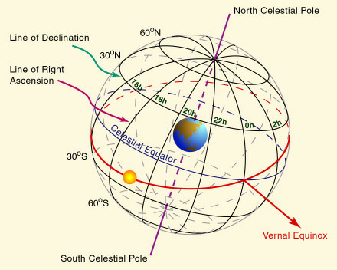
Directions: Complete the chart below for all of the stars in your constellation.

Some sites that may be helpful to you are:
- http://www.topastronomer.com/default.aspx
- http://www.constellationsofwords.com/

Star Name | Right Ascension (hour, min) | Declination  (degree, min) | Right Ascension (minutes as a fraction/60) | Declination (minutes as a fraction/60) | Right Ascension as a Decimal | Declination as a Decimal
Ex: Polaris | 2h 42m | 89° 18’ | 2h 42/60 | 89°18/60 | 2.7 | 89.3

Star Name | Right Ascension (hour, min) | Declination  (degree, min) | Right Ascension (minutes as a fraction/60) | Declination (minutes as a fraction/60) | Right Ascension as a Decimal | Declination as a Decimal
Ex: Polaris | 2h 42m | 89° 18’ | 2h 42/60 | 89°18/60 | 2.7 | 89.3

